Nearly 30 years ago it happened, that I detected the Golden Ratio very unexpectedly. The reason was just this simple geometrical exercise in a technical paper:

An equilateral triangular prism had to be sliced by two plane cuts into three bodies of the same volumes. Not too simple solutions were requested.

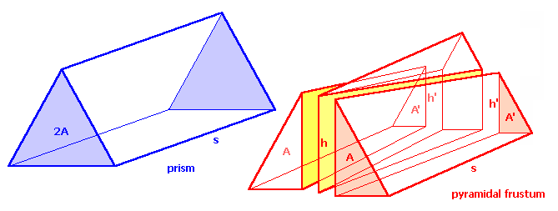

I called the triangular area 2A and gave the length s to the prism. On the right is shown, where I placed the two perpendicular cuts, beginning in h at the front area – ending in h’ at the rear side.

This way, two pyramidal frustums were created with a very complicated to describe piece between them.

volume of prism with area 2A: V_{prism} = 2A * s
volume of pyramidal frustum with areas A and A’: V_{frustum} = s/3 * (A + √(A*A’) + A’)
A’ substituted by A*x: V_{frustum} = s/3 * (A + √(A*A*x) + A*x)
simplified and squared: V_{frustum} = s/3 * A * (1 + x + x²)
the volume of the frustum will be exactly one
third of the prism-volume under the condition: 1 + x + x² = 2
this equation leads to a solution
in which I detected the golden ratio: x = (1/2) * [√(5) – 1)] = 0.618034
I did not think about this for more than 25 years. I only remembered now and again this h’ of the prism - from which I knew, that it embodies the golden ratio.
Now, there is enough time for me to care for such really important problems. So, I continued with development of an own method for a classical construction of h’. This is my suggestion:

1. Construct an equilateral triangle ABC together with its circumcircle.
2. Draw a parallel to AC through base-point D - the line cuts the circle in p *)
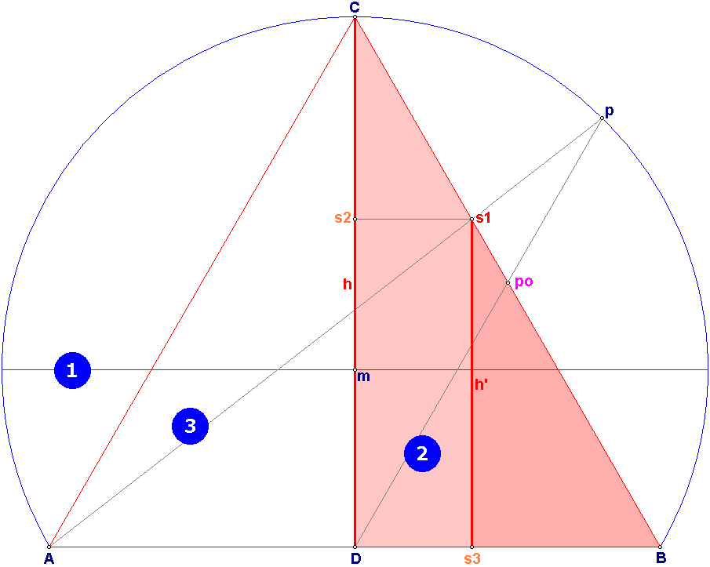
3. Draw a line from intersection-point p to A - the line cuts CB in point s1

I. s1 - the point of intersection separates CB in the golden ratio
II. s2 - horizontal projection of s1, separates CD in the golden ratio
- s3 - vertical projection of s1, separates DB in the golden ratio

*) This line is also known from the Odon-construction Dp:Dpo = Phi

