The Golden Ratio as Organizing Principle of the Economy
Bert de Groot & Rene Segers version 15 September 2026

HIGHLIGHTS
- In this article, we demonstrate both empirically and theoretically the existence of the golden ratio, φ, as an organizing principle of the wave-like movements in the economy.
- We introduce a dynamic mathematical model for investment behavior, inspired by Austrian business cycle theory.
- The model is quasi-periodic and satisfies the conditions of Kolmogorov–Arnold–Moser theory.
- We conclude that the cyclical motions within the model must not resonate in order to safeguard the stability of the system. This requires the ratios between the cycle lengths to be sufficiently irrational. The golden ratio, φ, is known as the most irrational ratio and therefore provides maximum system stability. The system is thus dynamically stable.
- Empirical findings in De Groot, Segers and Prins (2021, 2022) show that the ratios between subcycle lengths in the GDP of 25 OECD countries are indeed very close to the golden ratio.
- Individual variables such as consumer prices, employment, wages, interest rates, commodity prices, war and GDP also display subcycles. Cycles examined by scientists over 165 years of research show a clustering around numbers from the Fibonacci sequence. De Groot, E.A. (2006), De Groot, E.A., Franses, P.H.B.F. (2008, 2009, 2012). The golden ratio is the limiting value of the ratio between consecutive numbers in the Fibonacci sequence.
- The golden ratio is visible and active in both the micro- and the macro-economy.

SUMMARY
Schumpeter (1939) conjectured that there exist many, or perhaps even an indefinite number, of subcycles in an economy, but that in the long run only a few subcycles remain stable and persist, whereas others become unstable and cease. In this article, we build upon this idea, hypothesizing that, for a multiple cycle structure to persist, the cyclical lengths of subcycles should not be multiples of each other. We formalize our theory using a mathematical model for investment behavior, inspired by Austrian Business Cycle theory (ABCT). The model is quasi-periodic and satisfies the conditions of Kolmogorov–Arnold–Moser theory. This enables us to describe the dynamic properties of the model. We conclude that the cycles of the system should be non-resonant for the motion to remain stable in the long run. That is, that the ratios between the cycle lengths should be sufficiently irrational. The golden ratio, φ, satisfies this requirement. Coupled with the recent empirical findings of De Groot et al. (2021, 2022), who established the ratios between subcycle lengths in the gross domestic product (GDP) of 25 OECD countries and found them to be close to φ, we conclude that the cycles detected therein are non-resonant and remain stable. This puts Schumpeter's thesis on both a theoretical and an empirical footing, extended by the connecting factor φ. Because the factor φ pertains to both micro- and macro-economic variables, it constitutes an organizing principle in the economy.

Keywords: Economic cycle theory; Austrian business cycle theory; KAM theory; Golden ratio
All rights reserved by the authors. © E A de Groot & R Segers

1. Introduction
The analysis of economic cycles helps to signal future turning points and thereby to alleviate economic and societal distress. The field goes back to the revolutionary ideas of Kondratieff (1926, 1928), which inspired contemporaries such as Frisch and Tinbergen to mathematically model cycles (Frisch, 1933a; Tinbergen, 1939) — work for which they received the first Nobel Prize in Economics in 1969. Other influential contributions came from Burns and Mitchell (1947), Schumpeter (1939) and Stock and Watson (1998).
Many macro-economic indicators display not one, but multiple subcycles of varying length (De Groot and Franses, 2008; Korotayev and Tsirel, 2010; Sanidas, 2014; Schumpeter, 1939), but relatively little is known about their interrelationship. There exist two schools of thought in the literature. The first holds that the number of subcycles is small and that their lengths tend to become multiples of each other — a process known as entrainment (Forrester, 1977) or mode-locking (Berry, 2000); in this case the cyclical structures resonate. The second school of thought conjectures that there exist many, or perhaps even an indefinite number of subcycles (Schumpeter, 1939), of which in the long run only a few remain stable, that is, non-resonating cyclical structures. The idea is that subcycles with multiple lengths would lead to great economic instability (De Groot and Franses, 2008).
Although the empirical research predominantly points in the direction of the second school of thought (see the meta-analysis in Section 2), it lacks a dynamic mathematical model that explains why non-resonating subcycles persist and resonating subcycles cease. This article introduces such a model.

1.1. Sociobiological theory
Our model is inspired by biology (Devezas, 2005; Devezas et al., 2007; Hirshleifer, 1977, 1978; Linstone, 2006). Sociobiological theory holds that entities choose strategies that promote their survival (Hirshleifer, 1977). Similarly, economic agents optimize their decisions, which leads to competition, cooperation, conflict, learning and evolution (Hirshleifer, 1978; Devezas and Corredine, 2001).
Frisch (1932), Kondratieff (1926, 1928) and Schumpeter (1939) explain cyclical fluctuation from a biological mechanism; Schumpeter saw economic growth as driven by clusters of innovation followed by 'creative destruction'. The predator-prey model of Lotka and Volterra inspired Goodwin (1967, 1951) to develop a model of the interaction between employment and the wage share, which produces endogenous cycles in output, unemployment and wages (Feinstein and Dobb, 1967).
Other researchers have sought explanations for long, Kondratieff (K-) waves: Marchetti (1980) used Lotka–Volterra equations to demonstrate structured waves of innovation. Later applications concerned stocks and bonds (Modis, 1999) and banking (Thompson, 2011). Devezas and Corredine (2001) pointed to generational and cognitive drivers, and Modelski (2006) pointed to the relation with global political evolution.
We base our model on May (1978), who describes the population dynamics of insects and parasitoids, and reinterpret this for the growth of good investment versus malinvestment.

1.2. Austrian business cycle theory
Investment behavior is regarded by several researchers as the source of economic cycles (Greenwood et al., 1988; Justiniano et al., 2010) and is attributed to the marginal efficiency of investment (Keynes, 1936). Austrian business cycle theory (ABCT) places the credit issue at its foundation. Low interest rates in times of low activity stimulate borrowing and investment, which causes a boom, but also provokes malinvestments that inevitably lead to a downturn (Hayek, 1929; Rothbard, 1972; Von Mises, 1912). This pattern repeats itself, creating economic cycles. For a long time the ABCT received little support, but since the financial crisis of 2007–2008 its popularity has increased (Salerno, 2012; see also Keeler, 2001).

1.3. Kolmogorov–Arnold–Moser theory
Gidea et al. (2011) show that our model satisfies the Kolmogorov–Arnold–Moser (KAM) theory (Arnold, 1963; Kolmogorov, 1954; Möser, 1962; Chierchia and Pinzari, 2011), which describes the effect of small perturbations in quasi-periodic dynamic systems (Dumas, 2014). Such systems are periodic on a small scale but unpredictable on a larger scale. Under a perturbation, some motions remain stable — these satisfy the non-resonance principle, in which perturbations are not amplified and fade out — while other, resonating motions become unstable. A well-known example is the orbit of planets around the sun. With a single planet, the system is exactly solvable and stable, but with multiple planets, mutual gravitational forces perturb the orbits, and planets with a frequency ratio close to a fraction with a small denominator exhibit orbital resonance and become unstable (Ghys, 2007).
Applied to economic cycles, we assume that subcycles must be non-resonant in order to persist, that is, that their length ratios must be sufficiently irrational. De Groot et al. (2021) found that the ratios between subcycle lengths in the GDP growth of 25 OECD countries and Europe are close to the golden ratio φ — generally recognized as the most irrational number. Combined with this theoretical study, we conclude that these subcycles are likely non-resonant and therefore stable.
The remainder of this article is organized as follows. Section 2 provides a literature perspective and meta-analysis. Section 3 introduces the model. Section 4 discusses the dynamic properties via KAM theory. Section 5 contains the conclusion.

2. Literature perspective on multi-structured cycles

2.1. Earlier research

2.1.1. 150 years of research on economic cycles
Over the past 150 years, scientists from a wide range of disciplines — economics, econometrics, mathematics, statistics, physics and biology — have sought to explain the existence of economic cycles. Clarke (1847) was among the first to document cycles, dating back to 1202. Kondratieff (1926, 1928) extended the then-known cycles of 7–10 years with longer cycles of 48–60 years, which he attributed to technical change, wars, the assimilation of new countries into the world economy, and fluctuations in gold production. He regarded crises as an 'organic' part of capitalism (cf. Marx, 1867; Juglar, 1862).
Ragnar Frisch formulated, with his rocking-horse metaphor (Frisch, 1933a), one of the first mathematical models for economic oscillations. In 1969 he received, together with Tinbergen, the first Nobel Prize in Economics. He endorsed Kondratieff's theory (Frisch, 1927) and found subcycles of nine, twenty and fifty years in English price data (Frisch, 1933b). Tinbergen (1929) and Mitchell (1927) also responded positively to the work of De Wolff (1929) and Kondratieff (1926) on long waves.

2.1.2. Frisch's triple pendulum model
Frisch (1930) also developed a pendulum model, consisting of three pendulums of decreasing mass connected in series, inspired by sea waves at different scales (wind, storm, tide). As the mass of the lower pendulum becomes sufficiently small relative to the one above it, each pendulum oscillates approximately as if it were a free pendulum. The model remained a metaphor for multiple cycles for a long time. Research into it stopped because it was thought to be a chaotic system, which turns out not to be the case. De Groot et al. (2026) show that Frisch's pendulum model in many cases offers a more accurate description of the multiple cycles in the GDP of 25 OECD countries than conventional methods.

2.1.3. Harmonic analysis at the Business Research Institute of Moscow
While Frisch focused on mathematical models, a team at the Business Research Institute of Moscow — with Slutzky joining from 1926 — applied harmonic analysis, based on the Fourier analysis of Fourier (1822), to detect subcycles in macro-economic time series and to measure their lengths and amplitudes. This was inspired by Moore (1914, 1923), who aimed to establish a causal link between an eight-year economic cycle and meteorological patterns. These techniques are still used today, and served as a basis for Slutzky's research into the sources and composition of cycles (Klein, 1997; Slutzky, 1937; Vianna Franco et al., 2021).

2.1.4. Schumpeter's multiple cycle hypothesis
Schumpeter, who worked closely with Frisch, valued the pendulum model as a stylized representation of multiple cycles, but stressed that a mechanistic model does not do justice to structural change and evolution (Louçã, 2007). In his work he combined the long Kondratieff cycle with the medium-length Juglar and the short Kitchin cycle, with the proposition that “strictly speaking we should expect an indefinite number of cycles” (Schumpeter, 1939). As an example, he described the industrial revolution as a cluster of overlapping subcycles that together brought about a fundamental, itself also cyclical, change in the economic and social structure (Schumpeter, 1939, p. 168).

2.2. Research after the Second World War

2.2.1. Studying isolated subcycles
After the war, cycles were generally studied in isolation, with most attention devoted to the business cycle and the K-wave. Other documented cycles are the Kitchin (av. 3 yrs.), Juglar (8 yrs.), bootstrap (13 yrs.), Kuznets (21 yrs.), societal (34 yrs.), four-generation-cohort (90 yrs.) and war-and-hegemony cycle (145 yrs.) (Kitchin, 1923; Juglar, 1862; Forrester, 1977; Haustein and Neuwirth, 1982; Kuznets, 1930; Devezas and Corredine, 2001, 2002; Howe and Strauss, 2000; Strauss and Howe, 1992, 2009; Goldstein, 1988, 2003, 2006).
The business cycle, with an average length of approximately 5 years, is the most prominent subcycle in terms of amplitude. Much research has focused on forecasting its turning points (Mitchell and Burns, 1938; Hamilton, 1989; King et al., 1991; Stock and Watson, 1989). Real business cycle theory regards business cycle fluctuations as an efficient response to exogenous shocks (Kydland and Prescott, 1982; Mankiw, 1989) — an idea that goes back to Frisch (1933a).
The Kondratieff-wave literature centers on evidence for its existence and on possible driving forces; the topic has remained contested since Kondratieff's time (Garvy, 1943). For an extensive overview, see Coccia (2018); Grinin et al. (2017); De Groot and Franses (2012).

2.2.2. Theoretical work on multi-structured cycles
Forrester (1977) hypothesized that cycles align through entrainment into a locked solution with multiple lengths — much like pendulum clocks that synchronize in the same room. Mosekilde et al. (1992) modeled this mathematically. Larsen and Haxholdt (1997) demonstrated mode-locking in the Goodwin business cycle model (Goodwin, 1951). Berry (2000) introduced the notion of a pacemaker, a cyclical actor that forces other cycles into synchronization.
Other researchers instead fitted cycles together like pieces of a jigsaw puzzle (Reijnders, 1990): Van Duijn (1983) states that a Kondratieff wave consists of five Juglar cycles; Berry and Kim (1994) and Berry et al. (1993) combine generational waves (Strauss and Howe, 1992) with the Kondratieff wave. Tylecote (1994, 2013) places Kuznets swings within the Kondratieff wave and Kondratieff waves within hegemony waves (see also Goldstein, 1988; Thompson, 1990; Wallerstein, 1983).
Grinin and Korotayev (2014) and Grinin et al. (2016) modeled the interaction between the Juglar cycle and the Kondratieff wave and showed how the investment cycle affects the cycles in GDP, even though crises cannot occur without exogenous impulses.

2.2.3. Empirical work on multi-structured cycles
With new econometric methods, the lengths and amplitudes of subcycles have been measured in numerous studies, but little attention has been paid to their interrelationship. Table 1 presents a meta-analysis of publications in which two or more subcycles were econometrically measured in the same time series, with the ratios between consecutive cycle lengths (ordered from small to large). Standard errors are not available, so the ratios must be interpreted with caution.
Kuczynski (1978) found cycles of 2 to 60 years in worldwide production, consumption and innovation data, of which only the 2- and 8-year cycles are multiples of each other. Haustein and Neuwirth (1982) identified five cycles attributed to innovation in industrial production. Solomou (1998) found varying cycle lengths in the GDP of Germany, France, the UK and the US. Berry (2000) and Berry et al. (2001) found strongly coupled inflation cycles of 6, 9 and 18 years. De Groot and Franses (2008, 2009) found cycle lengths in macro-indicators and innovation data that align remarkably well with the Fibonacci sequence. Korotayev and Tsirel (2010) detected not-closely-coupled Kondratieff-wave, Juglar and Kitchin cycles in worldwide GDP dynamics.
Table 1
Ratios between the lengths of subcycles found in the literature.
Publication | Variable(s) | Country | Cycle lengths | Cycle length ratios
Kuczynski (1978) | Consumption, innovation, invention, production | World | 2, 8, 9, 23, 60 | 1.13, 2.56, 2.61, 4.00
Haustein and Neuwirth (1982) | Industrial production | World | 7, 13, 20, 32, 53 | 1.54, 1.60, 1.66, 1.86, 2.35
Solomou (1998) | GDP | Germany | 10.8, 23.8 | 2.20
 |  | France | 4.5, 7.7, 20 | 1.71, 2.60
 |  | UK | 8.6, 24.6 | 2.86
 |  | US | 5.0, 10.8, 19.2 | 1.78, 2.16
Berry (2000) | Inflation, GNP | US | 6, 9, 18.5, 55.5 | 1.50, 2.05, 3.00
Berry et al. (2001) | Inflation | World | 6, 9, 18 | 1.50, 2.00
De Groot and Franses (2008) | 13 macroeconomic indicators | Netherlands, UK, US | 10, 26, 58, 92 | 1.41, 1.79, 1.85, 2.60
De Groot and Franses (2009) | Basic innovations per year | World | 5, 13, 24, 34, 61 | 1.59, 2.23, 2.60
Korotayev and Tsirel (2010) | GDP | World | 3.5, 8, 52.5 | 2.30, 6.60
De Groot et al. (2021) | GDP | 25 OECD countries and Europe | 3–15* | 1.62**
Ratios are listed in ascending order.
* De Groot et al. (2021) estimated the lengths of 2 to 5 subcycles, with lengths between 3 and 15 years, in percentage GDP growth for 25 OECD countries individually, and for Europe.
** Average over all estimated cycle length ratios.
Inspecting the cycle length ratios in Table 1, we conclude that in GDP, and in closely related components including industrial production and consumption, none of the estimated subcycle lengths appear to be multiples of each other.
An overview of individual variables from the USA, UK and NL for GDP growth, national production index, employment, wage index, long- and short-term interest rates, consumer price index and population growth show multiple waves that are not multiples of each other (De Groot, Franses 2008). The proposition that cycle lengths fit the Fibonacci sequence (1, 1, 2, 3, 5, 8, 13, 21, 55, 89, 144, ..) cannot be rejected.
Finally, De Groot et al. (2021) found that the ratios between subcycle lengths in the GDP of 25 OECD countries and Europe lie remarkably close to the golden ratio, φ = ½(1+√5) ≈ 1.618 — a number closely related to the Fibonacci sequence. The estimated cycle lengths in De Groot et al. (2021) are presented in Table 2.
Table 2
Estimated cycle lengths for each of the 25 OECD countries and for OECD Europe
 | Cycle length in years
Country | 3-4 | 4-5 | 5-6 | 6-7 | 7-8 | 8-9 | 9-10 | 10-11 | 11-12 | 12-13 | 13-14 | 14-15
Australia | - | - | 5 | - | - | - | 9.3 | - | - | - | - | 14.7
Austria | - | - | - | 6 | - | - | 9.4 | - | - | - | - | 14.9
Belgium | - | 4 | - | - | - | - | 9.3 | - | - | - | - | -
Canada | 3.7 | - | - | 6.2 | - | - | - | - | - | 12 | - | -
Czech Republic | - | 4.4 | - | - | 7.1 | - | 9.3 | - | - | - | - | -
Denmark | 3.9 | - | - | - | 7.1 | - | - | - | 11.5 | - | - | -
Finland | - | - | 5.3 | - | - | - | 9 | - | - | 12.9 | - | -
France | - | - | 5.6 | - | - | - | 9.6 | - | - | - | - | -
Germany | - | - | 5.1 | - | - | - | 9.6 | - | - | - | 13.1 | -
Greece | 3.2 | - | - | 6.4 | - | - | 9 | - | - | - | - | -
Iceland | - | - | - | - | - | 8.4 | - | 10.6 | - | - | - | -
Ireland | 3.5 | - | 5.4 | - | 7.1 | - | 9.5 | - | - | - | - | 14.7
Italy | - | - | 5.4 | - | - | - | 9.9 | - | - | - | - | -
Japan | - | - | 5.5 | - | - | - | 9.3 | - | - | - | - | -
Korea | - | 4.7 | - | - | - | - | 9.2 | - | - | - | - | -
Luxembourg | - | 4 | - | - | 7.2 | - | 9.1 | - | - | - | - | 14.3
Mexico | - | - | 5.1 | - | - | 8.7 | - | - | 11.9 | - | - | -
Norway | - | - | - | 6.2 | - | - | - | 10.4 | - | - | - | -
OECD Europe | - | - | 5.5 | - | - | - | 9.5 | - | - | - | - | -
Portugal | 3.2 | - | - | - | - | - | 9.6 | - | - | - | - | -
South Africa | - | - | 5.4 | - | - | 8.2 | - | - | - | 12.8 | - | -
Spain | - | 4.9 | - | - | - | - | 9.2 | - | - | - | - | -
Sweden | - | - | 5.1 | - | - | - | 9.9 | - | - | - | - | -
The Netherlands | - | - | 5.4 | - | - | - | 9.5 | - | - | - | 13.6 | -
UK | - | - | 5 | - | - | 8.7 | - | - | - | - | - | 14
USA | 3.9 | - | 5.4 | 6.9 | - | - | - | - | 11.2 | - | - | -
Count | 6 | 5 | 14 | 5 | 4 | 4 | 18 | 2 | 3 | 3 | 2 | 5

2.2.4. The cycles of φ
If we accept that cycles with lengths that are multiples of φ apart are likely to co-exist in an economy, an interesting pattern emerges. When we start with a cycle of 3, 5 or 8 years and multiply by φ, we obtain the series 5, 8, 13, 21, 34, 55, 89 (close to 90) and 144 (close to 145). The resulting series also matches the results of De Groot and Franses (2012). Based on a meta-analysis of 88 detected cycles, documented in 51 studies, these authors found cyclical lengths to be clustered around 8, 21, 32 and 55 years. We outline here some of the main connections with the literature on long waves. Table 3 provides an overview.

Table 3
The cycles of φ.
Periodicity | Name of the cycle
3 years | Kitchin
5 years | Business
8 years | Juglar
13 years | Bootstrap
21 years | Kuznets
34 years | Societal
55 years | Kondratieff
90 years | Four-generation cohort
145 years | War and Hegemony
A cyclical length of 3 years is close to the well-known Kitchin cycle (Kitchin, 1923). The 5-year cycle is the business cycle, and Juglar (1862) found the credit and monetary cycle.
The 13-year cycle is attributed to the bootstrap phenomenon, as described by Forrester (1977) and Haustein and Neuwirth (1982). The bootstrap phenomenon arises when a sector uses part of its own output as a production factor. The signal to increase the supply of the production factor leads to operations that result in a reduction of supply. The 13-year cycle was also detected in industrial production (Kuczynski, 1978).
Cycles with a length of approximately 21 years were documented by de Wolff (1924), Kuznets (1930) and Kuczynski (1978). These cycles are attributed to investment in construction. These cycles initially occurred because of large-scale immigration to the US between 1870 and 1920. The 21-year cycle has also been documented by Abramovitz (1959) and Solomou (1998) in GDP, and by Haustein and Neuwirth (1982) and Kuczynski (1978) in innovations.
The 34-year cycle is attributed to regularities in human behavior (Devezas and Corredine, 2001; 2002). This is further described as “the cyclicality of social phenomena is embedded in the human biological structure” (De Groot and Franses, 2012, p. 62). The 34-year cycle is also reported in Löosch (1937), Haustein and Neuwirth (1982), Thio (1991) and Dent (1999).
The 55-year cycle is the well-known Kondratieff wave (Kondratieff, 1926; 1928) in economic variables such as prices, interest rates, wages, consumption, foreign trade and coal, pig iron, lead and wheat. The Kondratieff literature offers a great many references. See De Groot et al. (2021, 2022).
The so-called four-generation cohort cycle, with a length of approximately 90 years, has been extensively researched by Howe and Strauss (2000) and Strauss and Howe (1992, 2009). This cycle arises because generationally recessive and dominant generations alternate.
Finally, the 145-year cycle is attributed to war and hegemony. Hegemony is described by Goldstein (1988, 2003, 2006) as the ability of one country to center the world economy around itself. Within this context, Modelski (1978, 2006) describes the leadership cycle, Wallerstein (1983) the world system, and Organski (1958) the transfer of power. Modelski and Thompson (1988), Reijnders (2006; 1990), and Mandel (1995) found this cycle to be independent of the Kondratieff wave. The peaks of the Kondratieff wave are often confused with the hegemony wave.

3. A mathematical model for investment behavior
To formulate a theory for the persistence of non-resonating cycles, we develop a mathematical model for investment behavior, in the tradition of the ABCT. We base our model on the dynamic model of May (1978) for the populations of insects and their parasitoids, and reinterpret this in a macro-economic context. The insect population represents total investment I, and the parasitoid population represents malinvestment I(m), the fraction of investment that is not correctly allocated.
As more is invested, the share of malinvestment also grows. We specify this relationship such that the risk of malinvestment increases with the size of the existing malinvestment, which leads to a Poisson distribution of malinvestments (Lauwerier and Metz, 1986; Hassell, 2000). Under the assumption that investment and malinvestment share the same natural growth rate a — a simplification that makes the analysis in Section 4 possible — this results in the following specification:
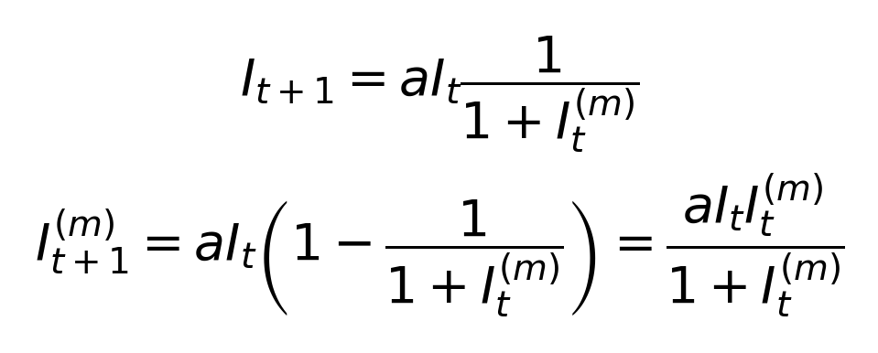 | (1)
To illustrate the model, we simulate the path of Eq. (1) with a = 1.3, an initial investment I1 = 1.0 and an initial malinvestment fraction I(m)1 = 0.5. Figure 1 shows the resulting growth rate of investment over time; the cyclical behavior of the model is immediately visible. Figure 2 shows the development of investment against malinvestment, that is, both quantities move cyclically around a long-term mean.
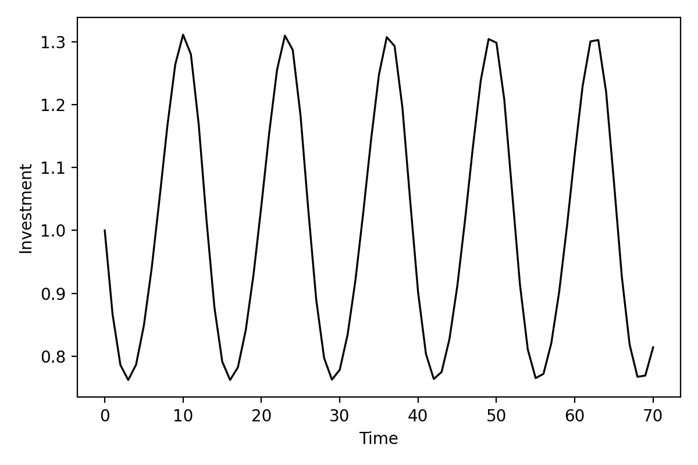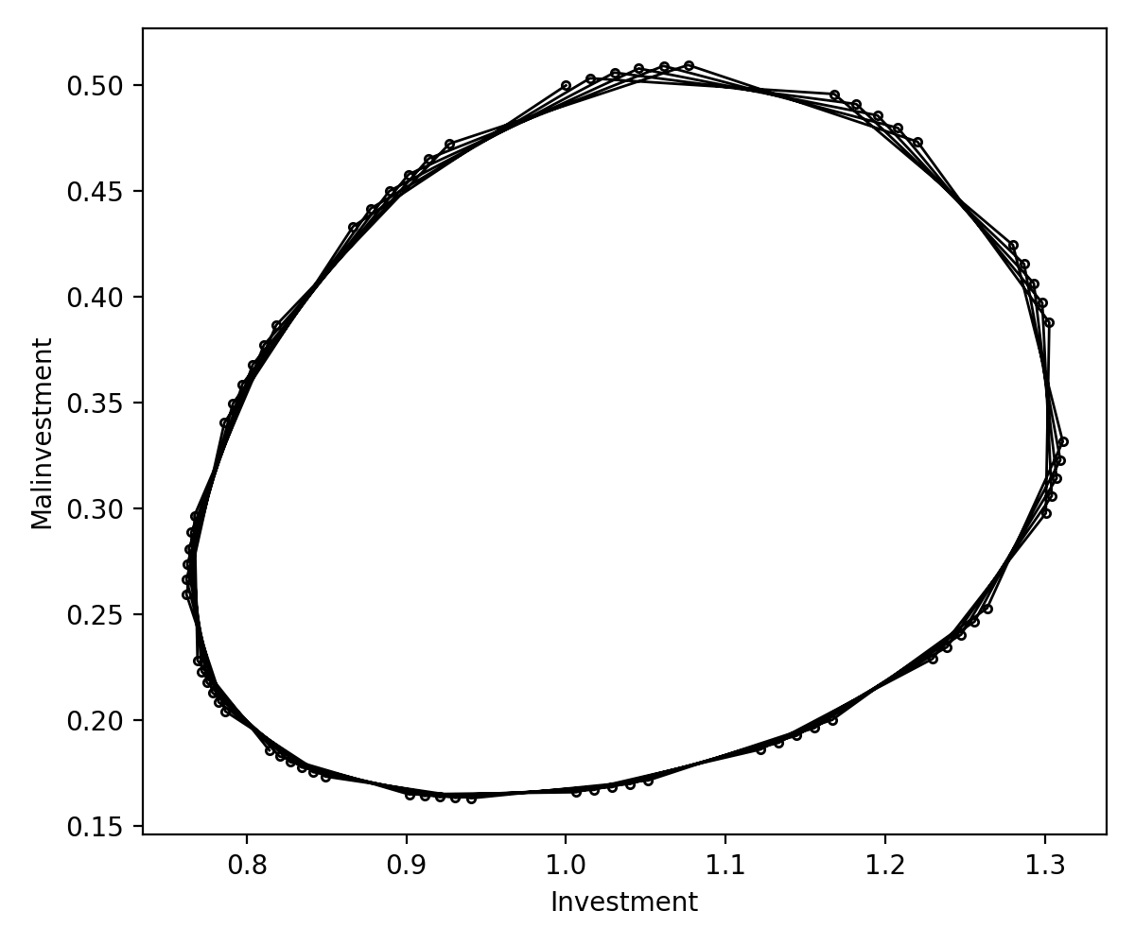
Fig. 1. Simulated investment series. Fig. 2. Simulated investment and malinvestment series
Figure 2 also shows that the system is stable, but does not exactly repeat itself: the system is quasi-periodic, that is, the ratio between the respective frequencies is irrational. We elaborate on this further in Section 4.

4. KAM theory and the model for investment behavior
In this section we analyze the dynamic properties of the investment behavior model using the Kolmogorov–Arnold–Moser (KAM) theory, which describes the effects of external shocks on quasi-periodic motions (Arnold, 1963; Kolmogorov, 1954; Möser, 1962). As we show, our model satisfies the required assumptions, allowing its dynamic properties to be derived.

4.1. Application of KAM theory to the investment behavior model
Applied to the economy, KAM theory implies that mature economic systems consist of non-resonating cycles. Resonating cyclical behavior persists only briefly, because every shock is amplified by the resonating motion until the system collapses — a phenomenon Forrester (1977) calls unstable cycles. Non-resonating cycles, by contrast, are less affected by external shocks and persist.
Gidea et al. (2011) show that our model in Eq. (1) satisfies the conditions of the KAM theorem, that is, it is area-preserving in the logarithmic coordinates
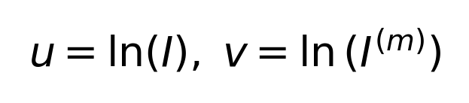 (2)
and has a non-trivial elliptic fixed point
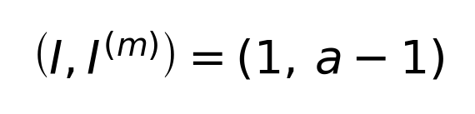 (3)
where
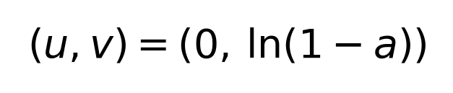 (4)
An elliptic fixed point does not necessarily attract or repel neighboring points. Because this fixed point is moreover non-degenerate and non-resonant (Gidea et al., 2011), KAM theory states that stable cycles persist as invariant closed curves around this point (Möser, 1962). Under a weak nonlinear perturbation of the system in Eq. (1), non-resonating cycles remain quasi-periodic, while others become unstable. Stable economic cycles thus do not resonate with one another.

4.2. Non-resonating cycles and the golden ratio
Greene (1979) shows that the most stable motions of a dynamic system display the least resonating cycles. This (non-)resonating behavior can be quantified via the ratios of the respective frequencies, that is, the more irrational this ratio, the more stable the motion. The degree of irrationality is measured via the continued-fraction representation
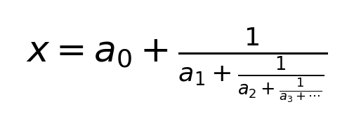 | (5)
For rational numbers this series is finite, for irrational numbers infinite; the larger the terms ai, the faster the rational approximation converges. The irrational number with the slowest convergence — and thus the worst rational approximation — has a continued fraction in which all terms equal 1:
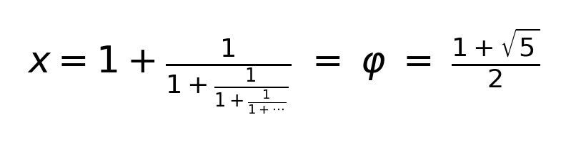 | (6)
This equation yields the golden ratio, φ = (1+√5)/2, a number rounding to 1.618.

5. The golden ratio as organizing principle of the economy

This article addresses two subjects. First, we discussed the origin of multiple economic cycles and the implicit relationships between cycle lengths. We showed empirically that the ratios between consecutive cycle lengths often closely match the golden ratio. Second, we introduced a dynamic model for investment behavior, inspired by Austrian business cycle theory, that satisfies the conditions of Kolmogorov–Arnold–Moser theory. This model shows that the cycles of the system must be non-resonant to ensure stability, and that the most irrational number, φ, maximizes this stability. The golden ratio, φ, thus constitutes the organizing principle of the economy.

References
Abramovitz, M., 1959. Historical and comparative rates of production, productivity and prices. Cited in: Solomou, S., Shimazaki, M., 2007. Japanese episodic long swings in economic growth. Explorations in Economic History 44, 224–241.
Arnold, V.I., 1963. Proof of a theorem of A.N. Kolmogorov on the preservation of conditionally periodic motions under a small perturbation of the Hamiltonian. Uspekhi Matematicheskikh Nauk 18, 13–40.
Berry, B.J.L., 2000. A pacemaker for the long wave. Technological Forecasting and Social Change 63, 1–23.
Berry, B.J.L., Kim, H., 1994. Leadership generations: a long-wave macrohistory. Technological Forecasting and Social Change 46, 1–9.
Berry, B.J.L., Kim, H., Kim, H.-M., 1993. Are long waves driven by techno-economic transformations? Evidence for the US and the UK. Technological Forecasting and Social Change 44, 111–135.
Berry, B.J.L., Kim, H., Baker, E.S., 2001. Low-frequency waves of inflation and economic growth: digital spectral analysis. Technological Forecasting and Social Change 68, 63–73.
Burns, A.F., Mitchell, W.C., 1947. Measuring Business Cycles. National Bureau of Economic Research, New York.
Chierchia, L., Pinzari, G., 2011. The planetary n-body problem: symplectic foliation, reductions and invariant tori. Inventiones Mathematicae 186, 1–77.
Clarke, H., 1847. Physical Economy: A Preliminary Inquiry into the Physical Laws Governing the Periods of Famines and Panics. Reprinted in Louçã, F., Reijnders, J. (Eds.), 1999. The Foundations of Long Wave Theory: Models and Methodology, Vol. 1. Edward Elgar, Cheltenham, pp. 3–20.
Coccia, M., 2018. A theory of the general causes of long waves: war, general purpose technologies, and economic change. Technological Forecasting and Social Change 128, 287–295.
De Groot, E.A., 2006. Essays on Economic Cycles. Erasmus University Rotterdam, ERIM Ph.D. Series Research in Management, No. 91.
De Groot, E.A., Franses, P.H.B.F., 2008. Stability through cycles. Technological Forecasting and Social Change 75, 301–311.
De Groot, E.A., Franses, P.H.B.F., 2009. Cycles in basic innovations. Technological Forecasting and Social Change 76, 1021–1025.
De Groot, E.A., Franses, P.H., 2012. Common socio-economic cycle periods. Technological Forecasting and Social Change 79, 59–68.
De Groot, E.A., Segers, R., Prins, D., 2021. Disentangling the enigma of multi-structured economic cycles - a new appearance of the golden ratio. Technological Forecasting and Social Change 169, 120793.
De Groot, E.A., Segers, R., Prins, D., 2022. Non-resonating cycles in a dynamic model for investment behavior. Technological Forecasting and Social Change 177, 121515.
De Groot, E.A., Segers, R., Gelderman, E., Hugenholtz, M.D., Slob, R.J.R., 2026. Frisch' Last Proposition. Submitted for publication.
Dent, H.S., 1999. The Roaring 2000's: Building the Wealth and Lifestyle You Desire in the Greatest Boom in History. Simon and Schuster, New York.
Devezas, T.C., 2005. Evolutionary theory of technological change: state-of-the-art and new approaches. Technological Forecasting and Social Change 72, 1137–1152.
Devezas, T.C., Corredine, J.T., 2001. The biological determinants of long-wave behavior in socioeconomic growth and development. Technological Forecasting and Social Change 68, 1–57.
Devezas, T.C., Corredine, J.T., 2002. The nonlinear dynamics of technoeconomic systems: an informational interpretation. Technological Forecasting and Social Change 69, 317–357.
Devezas, T.C., Linstone, H.A., Santos, H.J.S., 2007. The growth of the internet, long waves, and global change, in: Globalization as Evolutionary Process: Modeling Global Change. Routledge, London, p. 310.
De Wolff, S., 1924. Prosperitäts- und Depressionsperioden. Thüringische Verlagsanstalt und Druckerei, Leipzig.
De Wolff, S., 1929. Het Economisch Getij: Bijdrage tot de Verklaring van het Conjunctuurverschijnsel. J. Emmering, Amsterdam.
Dumas, H.S., 2014. The KAM Story: A Friendly Introduction to the Content, History, and Significance of Classical Kolmogorov-Arnold-Moser Theory. World Scientific Publishing Company, Singapore.
Feinstein, C.H., Dobb, M., 1967. Socialism, Capitalism and Economic Growth. Cambridge University Press, Cambridge.
Forrester, J.W., 1977. Growth cycles. De Economist 125, 525–543.
Fourier, J., 1822. Théorie Analytique de la Chaleur. Firmin Didot, Père et Fils, Paris.
Frisch, R., 1927. The Analysis of Statistical Time Series. Mimeo, Oslo University.
Frisch, R., 1930. Marginal and Limitational Productivity. Lectures at Yale University, Spring Term 1930, mimeo, Oslo University.
Frisch, R., 1932. Radio lectures, April 13 and 24, and May 12, 1932. Published as 'Konjunkturene', in Verdensøkonomien. Aschehoug, Oslo.
Frisch, R., 1933a. Editor's note. Econometrica 1, 1–4.
Frisch, R., 1933b. Propagation problems and impulse problems in dynamic economics, in: Economic Essays in Honour of Gustav Cassel. Allen & Unwin, London, pp. 171–205.
Garvy, G., 1943. Kondratieff's theory of long cycles. Review of Economics and Statistics 25, 203–220.
Ghys, E., 2007. Resonances and small divisors, in: Kolmogorov's Heritage in Mathematics. Springer, Berlin, pp. 187–213.
Gidea, M., Meiss, J.D., Ugarcovici, I., Weiss, H., 2011. Applications of KAM theory to population dynamics. Journal of Biological Dynamics 5, 44–63.
Goldstein, J.S., 1988. Long Cycles: Prosperity and War in the Modern Age. Yale University Press, New Haven.
Goldstein, J.S., 2003. War and economic history. The Oxford Encyclopedia of Economic History 5, 215–218.
Goldstein, J.S., 2006. The predictive power of long wave theory, 1989–2004. NATO Security through Science Series E: Human and Societal Dynamics 5, 137.
Goodwin, R., 1951. The nonlinear accelerator and the persistence of business cycles. Econometrica 19, 1–17.
Goodwin, R., 1967. A growth cycle, in: Feinstein, C.H. (Ed.), Socialism, Capitalism and Economic Growth. Cambridge University Press, Cambridge.
Greene, J.M., 1979. A method for determining a stochastic transition. Journal of Mathematical Physics 20, 1183–1201.
Greenwood, J., Hercowitz, Z., Huffman, G.W., 1988. Investment, capacity utilization, and the real business cycle. American Economic Review 78, 402–417.
Grinin, L.E., Korotayev, A.V., 2014. Interaction between Kondratieff waves and Juglar cycles, in: Kondratieff Waves: Cycles, Crises, and Forecasts. Uchitel Publishing House, Volgograd, pp. 25–95.
Grinin, L.E., Korotayev, A.V., Malkov, S.Y., 2016. The mathematical model of Juglar cycles and the current global crisis, in: Kondratieff Waves: Cycles, Crises, and Forecasts. Uchitel Publishing House, Volgograd, pp. 14–64.
Grinin, L.E., Grinin, A.L., Korotayev, A., 2017. Forthcoming Kondratieff wave, cybernetic revolution, and global ageing. Technological Forecasting and Social Change 115, 52–68.
Hamilton, J.D., 1989. A new approach to the econometric analysis of nonstationary time series and business cycles. Econometrica 57, 357–384.
Hassell, M.P., 2000. Host–parasitoid population dynamics. Journal of Animal Ecology 69, 543–566.
Haustein, H.-D., Neuwirth, E., 1982. Long waves in world industrial production, energy consumption, innovations, inventions, and patents and their identification by spectral analysis. Technological Forecasting and Social Change 22, 53–89.
Hayek, F.A., 1929. Geldtheorie und Konjunkturtheorie. Hölder-Pichler-Tempsky, Vienna.
Hirshleifer, J., 1977. Economics from a biological point of view. Journal of Law and Economics 20, 1–52.
Hirshleifer, J., 1978. Competition, cooperation, and conflict in economics and biology. American Economic Review 68, 238–243.
Howe, N., Strauss, W., 2000. Millennials Rising: The Next Great Generation. Vintage Books, New York.
Juglar, C., 1862. Des Crises Commerciales et leur Retour Périodique en France, en Angleterre, et aux Etats-Unis. Guillaumin, Paris.
Justiniano, A., Primiceri, G.E., Tambalotti, A., 2010. Investment shocks and business cycles. Journal of Monetary Economics 57, 132–145.
Keeler, J.P., 2001. Empirical evidence on the Austrian business cycle theory. Review of Austrian Economics 14, 331–351.
Keynes, J.M., 1936. The General Theory of Employment, Interest, and Money. Macmillan, London.
King, R.G., Plosser, C.I., Stock, J.H., Watson, M.W., 1991. Stochastic trends and economic fluctuations. American Economic Review 81, 819–840.
Kitchin, J., 1923. Cycles and trends in economic factors. Review of Economics and Statistics 5, 10–16.
Klein, J.L., 1997. Statistical Visions in Time: A History of Time Series Analysis, 1662–1938. Cambridge University Press, Cambridge.
Kolmogorov, A.N., 1954. On the conservation of conditionally periodic motions under small perturbation of the Hamiltonian. Doklady Akademii Nauk SSSR 98, 527–530.
Kondratieff, N., 1926. Die langen Wellen der Konjunktur. Archiv für Sozialwissenschaft und Sozialpolitik 56, 573–609.
Kondratieff, N., 1928. Die Preisdynamik der industriellen und landwirtschaftlichen Waren. Archiv für Sozialwissenschaft und Sozialpolitik 60, 1–34.
Korotayev, A.V., Tsirel, S.V., 2010. A spectral analysis of world GDP dynamics: Kondratieff waves, Kuznets swings, Juglar and Kitchin cycles in global economic development, and the 2008–2009 economic crisis. Structure and Dynamics 4.
Kuczynski, T., 1978. Spectral analysis and cluster analysis as mathematical methods for the periodization of historical processes, in: Proceedings of the Seventh International Economic History Congress, Vol. 2, pp. 79–86.
Kuznets, S., 1930. Secular Movements in Production and Prices, their Nature and their Bearing upon Cyclical Fluctuations. Houghton Mifflin, Boston.
Kydland, F.E., Prescott, E.C., 1982. Time to build and aggregate fluctuations. Econometrica 50, 1345–1370.
Larsen, E.R., Haxholdt, C., 1997. Mode-locking in a forced business cycle. Technological Forecasting and Social Change 56, 119–130.
Lauwerier, H.A., Metz, J.A.J., 1986. Hopf bifurcation in host–parasitoid models. Mathematical Medicine and Biology 3, 191–210.
Linstone, H.A., 2006. The information and molecular ages: will K-waves persist? NATO Security through Science Series E: Human and Societal Dynamics 5, 260.
Löosch, A., 1937. Population cycles as a cause of business cycles. Quarterly Journal of Economics 51, 649–662.
Louçã, F., 2007. The Years of High Econometrics: A Short History of the Generation that Reinvented Economics. Routledge, London.
Mandel, E., 1995. Long Waves of Capitalist Development: A Marxist Interpretation. Verso, London.
Mankiw, N.G., 1989. Real business cycles: a new Keynesian perspective. Journal of Economic Perspectives 3, 79–90.
Marchetti, C., 1980. Society as a learning system: discovery, invention, and innovation cycles revisited. Technological Forecasting and Social Change 18, 267–282.
Marx, K., 1867. Das Kapital: Kritik der Politischen Ökonomie. Verlag von Otto Meisner, Hamburg.
May, R.M., 1978. Host-parasitoid systems in patchy environments: a phenomenological model. Journal of Animal Ecology 47, 833–844.
Mitchell, W., 1927. Business Cycles: The Problem and its Setting. National Bureau of Economic Research, New York.
Mitchell, W.C., Burns, A.F., 1938. Statistical Indicators of Cyclical Revivals. National Bureau of Economic Research, New York.
Modelski, G., 1978. The long cycle of global politics and the nation-state. Comparative Studies in Society and History 20, 214–235.
Modelski, G., 2006. Global political evolution, long cycles, and K-waves. NATO Security through Science Series E: Human and Societal Dynamics 5, 293–302.
Modelski, G., Thompson, W.R., 1988. Seapowers in Global Politics, 1494–1993. Macmillan, London.
Modis, T., 1999. Technological forecasting at the stock market. Technological Forecasting and Social Change 62, 173–202.
Moore, H.L., 1914. Economic Cycles: Their Law and Cause. Macmillan, New York.
Moore, H.L., 1923. Generating Economic Cycles. The Macmillan Company, New York.
Mosekilde, E., Larsen, E.R., Sterman, J.D., Thomsen, J.S., 1992. Stability through cycles. Annals of Operations Research 37, 185–215.
Möser, J., 1962. On invariant curves of area-preserving mappings of an annulus. Nachrichten der Akademie der Wissenschaften in Göttingen, Mathematisch-Physikalische Klasse II, 1–20.
Organski, A.F.K., 1958. World Politics. Knopf, New York.
Reijnders, J., 1990. Long Waves in Economic Development. Edward Elgar, Cheltenham.
Reijnders, J., 2006. Did World War II reset the 'rhythm' of the Kondratieff wave? Kondratieff Waves, Warfare and World Security, 145–152.
Rothbard, M.N., 1972. America's Great Depression. Ludwig von Mises Institute, Auburn.
Salerno, J.T., 2012. A reformulation of Austrian business cycle theory in light of the financial crisis. Quarterly Journal of Austrian Economics 15, 3–44.
Sanidas, E., 2014. Four harmonic cycles explain and predict commodity currencies' wide long term fluctuations. Technological Forecasting and Social Change 87, 135–151.
Schumpeter, J.A., 1939. Business Cycles: A Theoretical, Historical and Statistical Analysis of the Capitalist Process. McGraw-Hill, New York.
Slutzky, E., 1937. The summation of random causes as the source of cyclic processes. Econometrica 5, 105–146.
Solomou, S., 1998. Economic Cycles: Long Cycles and Business Cycles since 1870. Manchester University Press, Manchester.
Stock, J.H., Watson, M.W., 1989. New indexes of coincident and leading economic indicators, in: Blanchard, O.J., Fischer, S. (Eds.), NBER Macroeconomics Annual. MIT Press, Cambridge, MA, pp. 352–394.
Stock, J.H., Watson, M.W., 1998. Business Cycle Fluctuations in US Macroeconomic Time Series. Technical Report, National Bureau of Economic Research, Cambridge, MA.
Strauss, W., Howe, N., 1992. Generations: The History of America's Future, 1584 to 2069. Harper Collins, New York.
Strauss, W., Howe, N., 2009. The Fourth Turning: What the Cycles of History Tell Us About America's Next Rendezvous with Destiny. Three Rivers Press, New York.
Thio, K., 1991. On simultaneous explanation of long and medium-term employment cycles. De Economist 139, 331–357.
Thompson, G., 2011. Sources of financial sociability: networks, ecological systems or diligent risk preparedness? Journal of Cultural Economy 4, 405–421.
Thompson, W.R., 1990. Long waves, technological innovation, and relative decline. International Organization 44, 201–233.
Tinbergen, J., 1929. Het ekonomiese getij. Sociaal Gids 14, 849–858.
Tinbergen, J., 1939. Statistical Testing of Business-Cycle Theories, Volume I: A Method and Its Application to Investment Activity. League of Nations, Geneva.
Tylecote, A., 1994. Long waves, long cycles, and long swings. Journal of Economic Issues 28, 477–488.
Tylecote, A., 2013. The Long Wave in the World Economy: The Current Crisis in Historical Perspective. Routledge, London.
Van Duijn, J.J., 1983. The Long Wave in Economic Life. Allen & Unwin, London.
Vianna Franco, M.P., Costa Ribeiro, L., Da Motta e Albuquerque, E., 2021. Beyond random causes: harmonic analysis of business cycles at the Moscow Conjuncture Institute. OSF Preprints. Center for Open Science.
Von Mises, L., 1912. Theorie des Geldes und der Umlaufsmittel. Duncker & Humblot, Munich and Leipzig.
Wallerstein, I., 1983. The three instances of hegemony in the history of the capitalist world-economy. International Journal of Comparative Sociology 24, 100–108.

Biography of the authors
Prof. dr. Bert de Groot is Professor at the Erasmus School of Economics, Erasmus University Rotterdam. Former CEO of Erasmus University Rotterdam Holding B.V. Former CFO and member of the Executive Board of Randstad Holding N.V. Rector Magnificus Emeritus of Nyenrode Business University.
Dr. Rene Segers is a guest researcher at the Erasmus School of Economics, Erasmus University Rotterdam, and partner at Gibbs Analytics Consulting B.V.
All rights reserved by the authors. © E A de Groot & R Segers

